**1) Implement the above code and paste the screen shot of the output.**

**Code**

#include <stdio.h>

int main() {

int buffer[10], bufsize, in, out, produce, consume, choice = 0;

in = 0;

out = 0;

bufsize = 10;

while (choice != 3) {

printf("\n1. Produce \t 2. Consume \t3. Exit");

printf("\nEnter your choice: ");

scanf("%d", &choice);

switch (choice) {

case 1:

if ((in + 1) % bufsize == out)

printf("\nBuffer is Full");

else {

printf("\nEnter the value: ");

scanf("%d", &produce);

buffer[in] = produce;

in = (in + 1) % bufsize;

}

break;

case 2:

if (in == out)

printf("\nBuffer is Empty");

else {

consume = buffer[out];

printf("\nThe consumed value is %d", consume);

out = (out + 1) % bufsize;

}

break;

}

}

}

**Output**

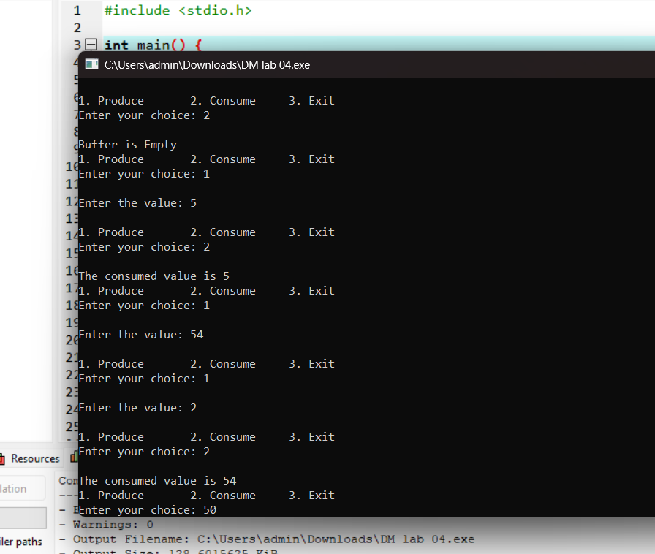

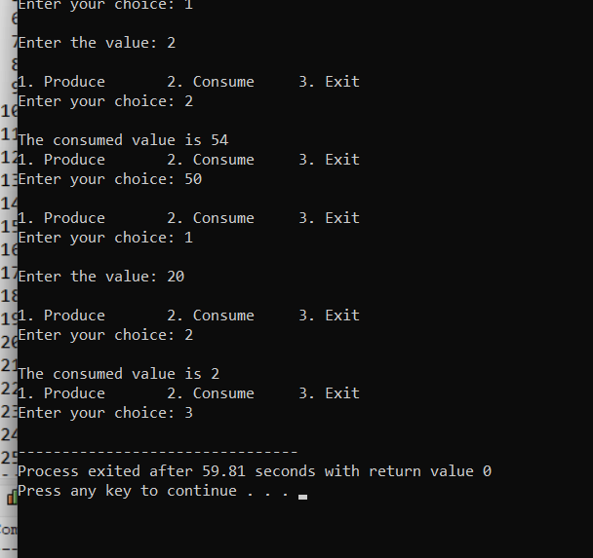

**2) Solve the producer-consumer problem using linked list. Note: Keep the buffer size to 10 places.**

**Code**

#include <stdio.h>

#define BUFFER_SIZE 10

typedef struct Node {

int data;

struct Node* next;

} Node;

Node* head = NULL;

Node* tail = NULL;

int count = 0;

pthread_mutex_t mutex;

sem_t empty, full;

void insert(int item) {

Node* newNode = (Node*)malloc(sizeof(Node));

newNode->data = item;

newNode->next = NULL;

if (tail == NULL) {

head = tail = newNode;

} else {

tail->next = newNode;

tail = newNode;

}

count++;

}

int remove_item() {

if (head == NULL) return -1;

Node* temp = head;

int item = temp->data;

head = head->next;

if (head == NULL) tail = NULL;

free(temp);

count--;

return item;

}

void* producer(void* arg) {

int item;

while (1) {

item = rand() % 100;

sem_wait(&empty);

pthread_mutex_lock(&mutex);

insert(item);

printf("Produced: %d\n", item);

pthread_mutex_unlock(&mutex);

sem_post(&full);

sleep(1);

}

}

void* consumer(void* arg) {

int item;

while (1) {

sem_wait(&full);

pthread_mutex_lock(&mutex);

item = remove_item();

printf("Consumed: %d\n", item);

pthread_mutex_unlock(&mutex);

sem_post(&empty);

sleep(1);

}

}

int main() {

pthread_t prod, cons;

pthread_mutex_init(&mutex, NULL);

sem_init(&empty, 0, BUFFER_SIZE);

sem_init(&full, 0, 0);

pthread_create(&prod, NULL, producer, NULL);

pthread_create(&cons, NULL, consumer, NULL);

pthread_join(prod, NULL);

pthread_join(cons, NULL);

pthread_mutex_destroy(&mutex);

sem_destroy(&empty);

sem_destroy(&full);

return 0;

}

**Output**

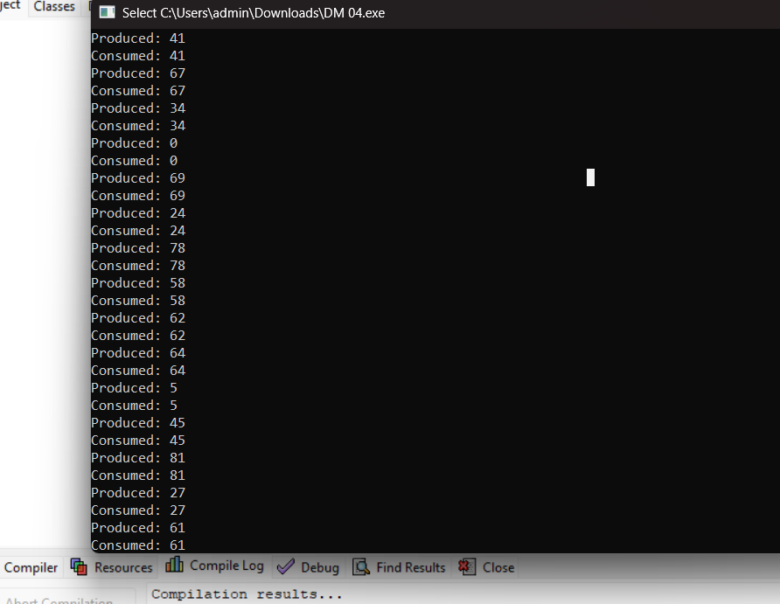

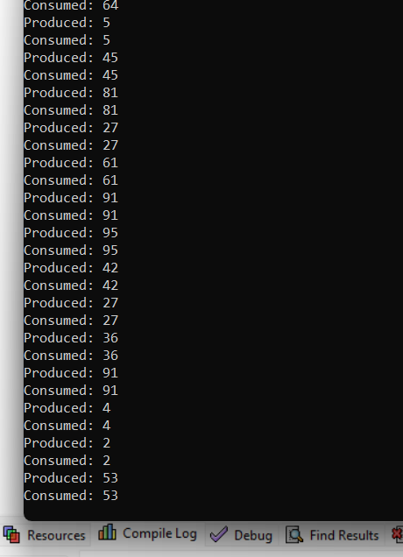

**3) In producer-consumer problem what difference will it make if we utilize stack for the buffer rather**

**than an array?**

Using a stack instead of a queue in the producer-consumer problem fundamentally changes the processing order from FIFO to LIFO, which may not be suitable for many traditional producer-consumer use cases.

**1) Implement the above code and paste the screen shot of the output.**

**Code**

#include <semaphore.h>

#include <stdio.h>

#include <stdlib.h>

#include <unistd.h>

#include <pthread.h>

sem_t x, y;

pthread_t tid;

pthread_t writerthreads[100], readerthreads[100];

int readercount = 0;

void *reader(void *param) {

sem_wait(&x);

readercount++;

if (readercount == 1) {

sem_wait(&y);

}

sem_post(&x);

printf("%d reader is inside\n", readercount);

usleep(3);

sem_wait(&x);

readercount--;

if (readercount == 0) {

sem_post(&y);

}

sem_post(&x);

printf("%d Reader is leaving\n", readercount + 1);

return NULL;

}

void *writer(void *param) {

printf("Writer is trying to enter\n");

sem_wait(&y);

printf("Writer has entered\n");

sem_post(&y);

printf("Writer is leaving\n");

return NULL;

}

int main() {

int n2, i;

printf("Enter the number of readers:");

scanf("%d", &n2);

int n1[n2];

sem_init(&x, 0, 1);

sem_init(&y, 0, 1);

for (i = 0; i < n2; i++) {

pthread_create(&writerthreads[i], NULL, reader, NULL);

pthread_create(&readerthreads[i], NULL, writer, NULL);

}

for (i = 0; i < n2; i++) {

pthread_join(writerthreads[i], NULL);

pthread_join(readerthreads[i], NULL);

}

return 0;

}

**Output**

